Developmental nutritional environment has persistent effects on honey bee resilience to virus infection

Alexander Walton, Amy Toth, Adam Dolezal

**INTRODUCTION**

Early-life nutrition can have long lasting or permanent effects on the phenotype. Because of the sensitivity of juvenile development to environmental input, the nutrition an individual receives in early stages of life can lead to morphological, physiological, neural, and epigenomic changes that permanently alter their adult phenotype (Gilbert 2017). In turn, these alterations can have important consequences for the behavior, health, and reproductive success of the individual. For example, when zebra finches experienced low food conditions as chicks, their spatial memory adults was impaired, however their spatial associated learning was enhanced (Kriengwatana et al. 2015). In humans and non-human mammals, mounting evidence shows that early-life nutritional deprivation leads to decreased adult survival and reproductive output (Lummaa and Clutton-Brock 2002; Briga et al. 2017; Griffin et al. 2018), effects which can span generations as even the offspring of these individuals may be underweight and underdeveloped (Albon et al. 1987; Meikle and Westberg 2001; Burton and Metcalfe 2014). Similar effects of early-life nutrition occur in insects. For example, when nutritionally deprived as juveniles, adult female cockroaches had reduced reproductive lifespan, an effect that could not be reversed with enriched diet as adults (Barrett et al. 2009). Although animals may be able to buffer some of the effects of early-life nutritional stress by reallocating resources to critical functions during development (Birkhead et al. 1999), or by adopting alternative life history strategies as adults (Emlen 1997; Wang et al. 2006), these compensatory mechanisms can be costly (Birkhead et al. 1999). Thus, the effects of early-life nutrition are long-reaching, with the potential to shape all aspects of the adult phenotype.

The honey bee *Apis mellifera* has served as a powerful system for understanding how nutrition shapes development. Honey bees are social insects that live in colonies comprised of male drones, functionally sterile female workers, and a single reproductive female queen. Drones are haploid, but all females are diploid. Whether a developing female larva will become a worker or queen is driven by timing of diet quality she receives. All feeding is performed by adult ‘nurse’ bees; these young worker bees process food into nutrient-rich glandular secretions that are used to provision larvae (e.g., royal jelly). For the first three days of larval development, all female larvae are provisioned with a high quality diet made up solely of these secretions. After this point, the nurse workers switch the provisioning of the majority of larvae to a lower quality diet that also contains pollen. Those that continue to receive the royal jelly alone develop into queens, while those fed the lower quality diet develop into workers (Winston, 1987). The nature and timing of this developmental switch has been thoroughly studied, and a clear picture is emerging of how nutrition mediates critical gene expression cascades and hormonal modulation to determine caste fate (Rembold et al. 1974; Kucharski et al. 2008; Mutti et al. 2011; Roth et al. 2019; Slater et al. 2020). Despite this work on honey bee queen/worker development as a model for disentangling environmental and genetic determinants of phenotype, comparatively little is known about the effects of developmental nutrition on adult phenotype within the worker caste. It is clear, however, that a worker’s developmental environment can have important lifelong effects, including effects on their ability to forage and recruit foragers (Scofield and Mattila 2015), their aggressiveness (Rittschof et al. 2015), and their cooperativeness (Walton et al. 2018) as adults.

In adult honey bee workers, however, many recent studies have focused on how nutrition or nutritional deprivation affects traits like immune response and resilience to pathogens. Concerns about landscape simplification and reduced floral resources have led to hypotheses of how reduced nutrient availability synergizes with increasingly widespread pathogen pressure, leading to increased morbidity and mortality (Naug 2009; Alaux et al. 2017; Dolezal and Toth 2018; Dolezal et al. 2019a). An improved adult diet could mitigate these effects by maintaining immunocompetence (Alaux et al. 2010). For example, the detrimental effects of the microsporidian gut parasite *Nosema ceranae* can be offset by pollen quantity (Jack et al. 2016), quality, and diversity (Di Pasquale et al. 2013). The most detrimental stressor most honey bees face, however, is pressure from the parasitic mite *Varroa destructor*. These ectoparasites feed on the hemolymph and fat body of developing and adult bees (Ramsey et al. 2019) and also vector a variety of highly detrimental viruses (Grozinger and Flenniken 2019; Traynor et al. 2020). Nutrition has been shown to affect incidence of several of these viruses, including deformed wing virus (DWV; DeGrandi-Hoffman et al. 2010) and black queen cell virus (BQCV). Experimental adult feeding and infection experiments have also shown adult pollen diet can affect survivorship (Dolezal et al. 2019a) and transcriptional responses (Rutter et al. 2019) to Israeli acute paralysis virus (IAPV). IAPV is a widespread virus (Chen et al. 2014) that has been associated with large-scale colony loss (Cox-Foster et al. 2007), and it produces distinct pathological phenotypes including shivering, paralysis, and death in a relatively short and repeatable window (Maori et al. 2009; Hsieh et al 2020). As such, IAPV provides a valuable system to use an economically relevant honey bee virus to investigate whether different types of nutritional stimuli can affect the resilience of bees to disease. Emerging research has highlighted the importance of adult nutritional environment in mitigating the effects of IAPV (Dolezal et al. 2019; Rutter et al. 2019; Hsieh and Dolezal *submitted)*. It is not clear, though, how developmental nutrition affects adult phenotypes in response to virus challenge.

In this study, we combine two different experimental nutritional manipulations to investigate how developmental nutrition affects bees’ resilience to virus infection and then seek to understand the underpinnings of these differences. We hypothesized that both bees who experience either a short-term period of starvation during development and those reared in colonies chronically fed only with low quality pollen would develop into seemingly-normal adult workers with increased sensitivity to infection, likely through modulation of immune responsiveness. We predicted that this would manifest in different levels of survivorship when faced with an IAPV challenge and be associated with differential gene expression of key immune response genes. We present evidence that both forms of nutritional stress can significantly reduce bees’ resilience to infection with important ramifications to our understanding of how developmental nutrition affects pathogen responses, particularly within the complex network of environmental stressors faced by pollinators.

**METHODS**

**Honey bee source**:

For all experiments, honey bee subjects were derived from colonies managed at the Iowa State University Horticulture Research Station in Ames, IA. All were produced from open-mated queens from commercial stocks.

**Experiment 1: Acute larval starvation**

First, we sought to produce honey bee adults that experienced a highly standardized form of nutritional deprivation as larvae but were still reared under mostly normal colony conditions. To do so, we used a protocol identical to that described in Walton et al 2018, as modified from Wang et al. 2014, 2016b, 2016a. Five queens from five separate honey bee colonies were caged over a frame of drawn, empty comb, for 48h. After this interval, the cages were removed and frames placed back into the colony; eggs were then allowed to hatch and larvae mature as normal. At 180h after the egg laying interval, the acute starvation treatment, or a control treatment, was performed on each frame as follows. Frames were removed from the colony and nurse bees brushed off the frame completely. A wire push-in cage was then placed over half of the developing larvae, preventing nurse bees from accessing them for feeding; the other half of the larvae on the frame remained accessible. Each frame was outside of the colony <2 minutes during the treatment. The frame was returned to the colony for 10 h, with bees maturing to approximately the developmental stage where larvae initiate spinning and stop feeding (Jay 1963). After this point, the frames were taken from the frames briefly and the push in cages removed, again allowing access by adult workers. Because honey bee larval development is highly regimented, focusing our starvation period to end at the spinning phase does not allow a window for compensatory feeding by the workers; i.e., they cannot feed the starved workers more after the treatment. After the starvation treatment, frames were returned to the colony and the pupae allowed to mature normally to the pharate stage (20 days after oviposition), after which they were removed from the colony and placed in an incubator at 33C overnight. Separate enclosures were placed over each treatment (starved vs control) on each frame to keep emerging adults separate. Once adults had emerged, the treatment and control bees were separated and the resulting bees mixed between the five colony sources. Within the first 24h after emergence, they were then separated into observation cages and treated as described below. This procedure was repeated twice, thus producing two separate generations of workers that experienced control or starvation conditions within the same colonies.

**Experiment 2: Pollen quality limitation**

While Experiment 1 allows a repeatable, standardized nutritional treatment, it is also confounded by the restriction of nurse bees performing other behaviors with the developing larvae, such as grooming and cleaning. In addition starvation, honey bee nutrition can also be affected by the quantity or quality of the food they have access to; recent years have seen an increasing focus on understanding how different nutritional sources affect bees’ resilience to other stressors (Wright et al. 2018; Mogren et al. 2019). Therefore, we performed a second set of experiments where we sought to produce adult bees that experienced chronic differences in nutrition during the entirety of development. This manipulation poses a challenge, as honey bees will not rear larvae successfully if the colony is under full starvation conditions (Schmickl and Crailsheim 2001). Instead, we produced experimental colonies that received pollen diets from single-source pollens that are both naturally collected by bees and have previously been associated with causing different responses to immune challenge (Di Pasquale et al 2013; Dolezal et al 2019; Rutter et al 2019).

To accomplish this, in July 2015, we constructed four experimental colonies as the mechanism for delivering the nutritional treatment to our focal larvae. Two colonies would receive high quality *Castanea spp.* pollen and the other two putatively lower quality *Cistus* *sp.* pollen. Each of these colonies was housed in a standard single deep box per standard beekeeping protocols. Each hive contained ten frames, as follows: two drawn (i.e., covered in wax comb) but empty frames; two drawn frames with one side filled with honey; one frame with capped brood (pupae); 5 frames of foundation (to be removed later). Great care was taken to only use frames that contained no stored pollen.

Bee populations in these hives were initiated by brushing frames of nurse bees from four brood-containing frames from six different colonies (i.e., 24 frames of bees) into a single container. These were then mixed gently to create a large homogenate of worker bees. From this mixture, approximately 4000 workers were measured out by volume (1.3 liters) and added to each of the four experimental hives. As such, each hive began the experiment with an approximately identical worker population from a single homogenated worker source. Each colony also received a standardized queen signal, in the form of a commercially available pseudoqueen (Mann Lake, LTD, Minnesota); use of this standardized signal removes variation in behavior that may occur due to different queen quality stimuli sensed by the workers.

To differentiate the hives by nutritional treatment, each colony was fitted with a ‘front porch’ style pollen trap (DeGrandi-Hoffman et al. 2016) that was constantly engaged. This device knocks the majority of the pollen off of the legs of returning foragers, effectively precluding the colony from accessing pollen resources from the landscape while allowing for free flight of workers and collection of nectar. Instead, each colony received an experimental pollen treatment. 10 grams of pollen was placed into hives every other day by filling a lid from a Falcon 50mL centrifuge tube (Thermo Fisher Scientific) with *Castanea* or *Cistus* pollen, which was then pushed into the wax on a frame. Because the pollen was replaced before it was completely consumed, each colony was provided *ad libitum* access to their respective pollen treatment, but was not able to gather pollen resources from natural forage.

Because the nutritional status of the workers decides the quality of food delivered to the larvae, it was necessary to first maintain these colonies under experimental conditions for multiple generations of workers to ensure the nutritional treatment was established. The first generation of workers were those in the original colony production, made up of a mixture of workers from wild type colonies; these would first start to be succeeded by the bees emerging from the capped brood frame initially present in the experimental colony. These bees, while experiencing normal larval development, emerged as adults into the nutritional treatment. A second and third frame of pupae was added to each colony once per week for the next three weeks. Also added to each colony were frames of eggs derived from one of four different queens in the general apiary; these provided larvae for the workers to care for to simulate a normal colony environment in the lead up to the production of the focal bees. When placed into each experimental hive, a frame of undrawn foundation was removed to make space. At 21 days after the creation of the colony (the duration of a worker bees’ development from egg to adulthood), two frames, each partially filled with newly-laid eggs from different unmanipulated queens, were added to each colony. These eggs were allowed to develop normally within the colony until the they had reached the pharate stage (with cells capped), after which they were removed to a 33C incubator for adult emergence. Once adults had emerged, they were mixed by treatment (i.e., all of the bees derived from *Cistus-*treated hives were combined and homogenized) and separated into observation cages for treatment as described below. This procedure was repeated twice more, once 14 days after the original addition of focal eggs, and once more 14 days after that. Each iteration used eggs derived from different, randomly-selected queens. Thus, we produced three separate generations of adults that experienced the hive nutritional treatment. Throughout this period, approximately 500 newly-emerged non-focal adults were added to each colony per week to ensure continuation of a stable population that experienced the hive nutritional treatment for their entire adulthood.

**Body analysis of nutritional treatments**

For each nutritional treatment, body mass and total lipid content was measured on a subset of newly-emerged bees (pre-virus treatment) that were not used in the cage assays. For experiment 1, 16 bees from the starvation treatment and 20 from the normal diet treatment were weighed; 6 from each treatment were assayed for lipid content. For experiment 2, 12 *Cistus-*reared and 10 *Castanea-*reared bees were weighed and measured for lipid content. Lipid content was assayed as described in Toth and Robinson 2005, as modified by (Dolezal et al. 2016b).

**Cage assays**

For both experiments, newly-emerged bees were assorted into cages and assayed for survival against a challenge with a virus inoculum previously shown to cause repeatable mortality due to infection primarily with Israeli acute paralysis virus (IAPV) using methods identical to those described in Dolezal et al 2019, as modified from Carrillo-Tripp et al 2016. In short, 35 newly emerged bees derived from the treatment-specific mixture of bees were placed into an acrylic observation cage (dimensions: 10.6 × 10.16 × 7.62 cm). Within 2h of the formation of each cage, a small weigh boat containing 600 µl of 30% sucrose solution was placed on the floor of each cage. Control cages received only sterile sucrose solution; virus treatment cages received a 1:1000 dilution of a virus inoculum, identical to that described in Carrillo-Tripp et al 2016 and Dolezal et al 2019. After 16 h, the solution in each cage had been completely consumed by the workers; then, a top feeder of sterile 30% sucrose solution was added to the top of each cage, providing virus-free diet *ad libitum* for the remainder of the experiment. Mortality in each cage was monitored each day for four (96h) days, the duration previously shown to be necessary to observe virus-induced mortality (Maori et al. 2009; Carrillo-Tripp et al. 2016). At 36 hours post-infection (hpi) 3 live bees were sampled from each cage for virus titer and gene expression analysis.

Thus, for Experiment 1, there were four cage treatments: starvation+sucrose control; starvation+virus; normal diet+sucrose control; starvation+virus. The first generation of workers reared under treatment conditions were used to produce 39 cages (n=9 for starvation+virus; n=10 for all others); the second generation produced 40 more cage (n=10 per treatment), for a final of 79 total cages (n=19 for starvation+virus; n=20 for all others). For experiment two, there were also four cage treatments, spread across three generations: *Cistus-reared*+sucrose control; *Cistus*-*reared*+virus; *Castanea-reared*+sucrose control; *Castanea-reared* +virus. Because there were more variable numbers of bees reared in the more natural but less controlled conditions, the number of cages produced from each generation was more variable, as follows. *Cistus-*reared+sucrose control (generation 1, n=8; generation 2, n=5; generation 3, n=8; total n=21); *Cistus*-reared+virus (generation 1, n=9; generation 2, n=6; generation 3, n=7; total n=22 ); *Castanea*-reared+sucrose control (generation 1, n=3; generation 2, n=6; generation 3, n=2; total n=11); *Castanea-*reared+virus (generation 1, n=3; generation 2, n=6; generation 3, n=2; total n=11).

**Virus titration**

From the 6 bees collected from each cage at 36 hours post treatment, RNA was extracted and IAPV titer measured from the pooled RNA of bees from 10 randomly-selected subsets of cages from each treatment; this was done identically to the methods of Dolezal et al 2019 and Geffre et al. 2020. In short, RNA was extracted from each sample using Trizol reagent. This material was then cleaned and treated with DNAse. RNA concentration was then equalized across all samples and measured via qPCR against an RNA standard curve used to estimate viral genome equivalents.

**Gene expression**

To measure gene expression, we used the RNA extracted for virus titration (above). qPCR was performed with the CFX384 TouchTM Real-Time PCR Detection System. We used the gene *actin* as an internal reference to normalize gene expression data, and the gene. We used the 2−ΔΔCT method (Livak and Schmittgen 2001) to calculate relative gene expression, with expression normalized to the internal control gene *rp49*, and shown relative to the “normal diet + sucrose control” treatment as the reference group in Experiment 1 and the “*Castanea* + sucrose control” treatment as the reference group in Experiment 2.

**Statistical analysis**

For all experiments, analyses were performed in R using version 3.3.1 (R Core Team 2016). For experiments 1 and 2, survival against the virus challenge was analyzed by comparing the proportion of each cage that survived the bioassay between the treatments via a linear mixed effects model using the lmer function from the package lme4 (Bates et al. 2015), with treatment generation as a random factor. ANOVAs followed by a Tukey HSD posthoc test, using the package multcomp (Hothorn et al. 2008), were performed on these models. Mass and lipid contents were compared using Welch’s t-test. Virus titers were log transformed to meet assumptions of normality and then compared across treatments using the same mixed model approach as described for survival. We made mixed effects models for gene expression with treatment generation as a random factor using the lmer function from lme4 (Bates et al. 2015) performed posthoc Tukey HSD contrast with emmeans function in the package emmeans (Lenth et al. 2020).

**RESULTS**

**Experiment 1** : Acute larval starvation

**Body quality analysis:** Bees reared under the acute starvation conditions weighed significantly less than those reared under normal diet conditions (Welch’s t-test, t=3.53, d.f.=33.13, p=0.0012; nstarvation=16; nnormal=20), but the proportion of their mass made up of lipids did not differ (Welch’s t-test, t=-2.16, d.f.=7.27, p=0.067; nstarvation=6; nnormal=6). Supplementary figure?

**Virus challenge bioassay**: Across the four nutrition/virus treatments, there were significant differences in the proportion of bees that died during the 96h assay (Figure 1a; mixed model ANOVA across all treatment groups, d.f. = 3, 6; *F=* 40.45*;* p <0.0001; nstarvation+virus=19; n=20 for all others), with all treatment groups significantly different from each other (Tukey HSD, p< 0.001) except the starvation+sucrose and normal diet+sucrose groups (Tukey HSD, p=0.28).

**IAPV titers:** Across the four nutrition/virus treatments, there were significant differences in the IAPV titers of bees collected 36h into the assay (Figure 1b; mixed model ANOVA across all treatment groups, *F=* 13.6; p <0.0001; n=10 per treatment), with all treatment groups significantly different from each other (Tukey HSD, p< 0.001) except the starvation+sucrose and normal diet+sucrose groups (Tukey HSD, p=0.52) and the starvation+virus and normal diet+virus (Tukey HSD, p=0.79).

**Gene expression:** Diet and viral treatments had varying effects on expression of the five immunity genes measured in this study (Figure 2).

*Effects of full diet+virus treatment*:See Supplemental Table 1 for individual statistics for all post-hoc contrasts. For the genes *cactus*, *hopscotch*, and *hymenoptaecin*, expression was higher in the starvation+virus treatment bees than normal+sucrose treatment bees, and not significantly different between any other treatment comparisons (*cactus*:ANOVA across all treatment groups, d.f. = 3, 24; *F*= 5.38; p=0.006; nnormal*+*sucrose=9, nnormal*+*virus=6, nstarved*+*sucrose =7, nstarved*+*virus =6, Tukey HSDstarved+virus – normal+sucrose p=0.004; *hopscotch*: ANOVA across all treatment groups, d.f. = 3, 30; *F*= 3.19; p=0.04; nnormal*+*sucrose=9, nnormal*+*virus=9, nstarved*+*sucrose =7, nstarved*+*virus =9, Tukey HSDstarved+virus – normal+sucrose p=0.02; *hymenoptacin*:ANOVA across all treatment groups, d.f. = 3, 31; *F*= 2.99; p=0.04; nnormal*+*sucrose=9, nnormal*+*virus=9, nstarved*+*sucrose =8, nstarved*+*virus =9, Tukey HSDstarved+virus – normal+sucrose p=0.04). There were no significant differences in expression across treatments for the genes *dicer* or *vitellogenin.*

*Effects of diet treatment only*: Bees that were acutely starved as larvae exhibited higher expression of the genes *cactus*, *hymenoptaecin*, and *vitellogenin* than bees reared normally (*cactus*: ANOVA, d.f. = 1, 26; *F*= 10.18; p=0.004; nnormal =15, nstarved =13; *hymenoptaecin*:ANOVA, d.f. = 1, 33; *F*= 7.25; p=0.01; nnormal =18, nstarved =17; *vitellogenin*: ANOVA, d.f. = 1, 31; *F*= 5.03; p=0.03; nnormal =16, nstarved =17; larval diet contrast results averaged over viral treatment).

*Effects of virus treatment only*: Bees that were inoculated with IAPV exhibited higher expression of the genes *dicer*, and *hopscotch* than control bees (*dicer*: ANOVA, d.f. = 1, 33; *F*= 5.93; p=0.02; nsucrose =17, nvirus =18; *hopscotch*:ANOVA, d.f. = 1, 32; *F*= 5.68; p=0.02; nsucrose =16, nvirus =18; viral contrast results averaged over diet treatment).

**Experiment 2**: Pollen quality limitation

**Body quality analysis:** There were no significant differences in the mass or lipid content of bees from the *Castanea* and *Cistus* treatments (Welch’s t-test, p>0.05; n*Cistus*=12, n*Castanea*=10; ).********I can’t find these numbers right now but could add ‘em

**Virus challenge bioassay**: Across the four nutrition/virus treatments, there were significant differences in the proportion of bees that died during the 96h assay (Figure 3a; mixed model ANOVA across all treatment groups, d.f. = 3, 6; *F=* 4.7; p <0.005; n*Cistus+*sucrose=21, n*Cistus+*virus=22, n*Castanea+*sucrose =11, n*Castanea+*virus =11). Comparing between the treatments, the *Cistus*-reared+virus vs. *Cistus*-reared+sucrose (Tukey HSD, p< 0.004) and *Cistus*-reared+virus vs. *Castanea-*reared+control (Tukey HSD, p=0.024) were significantly different, but no other groups were (Tukey HSD, p>0.05).

**IAPV titers:** Across the four nutrition/virus treatments, there were significant differences in the IAPV titers of bees collected 36h into the assay (Figure 3b, mixed model ANOVA across all treatment groups, d.f. = 3, 6; *F=* 6.46; p <0.0026; n*Cistus+*sucrose=5, n*Cistus+*virus=12, n*Castanea+*sucrose =2, n*Castanea+*virus =5). Comparing between the treatments, the *Cistus*-reared+virus vs. *Cistus*-reared+sucrose (Tukey HSD, p< 0.001) and *Cistus*-reared+virus vs. *Castanea-*reared+control (Tukey HSD, p=0.0148) were significantly different, but no other groups were (Tukey HSD, p>0.05).

**Gene expression:** Diet and viral treatments had varying effects on expression of the five immunity genes measured in this study (Figure 4).

*Effects of full diet+virus treatment*:See Supplemental Table 2 for individual statistics for all post-hoc contrasts. *Cactus* was more highly expressed in *Cistus*-reared+virus bees than in the other treatments(mixed model ANOVA across all treatment groups, d.f. = 3, 13.2; *F*= 18.05; p=0.0002; n*Cistus+*sucrose=5, n*Cistus+*virus=9, n*Castanea+*sucrose =5, n*Castanea+*virus =0). *Dicer* was more highly expressed in *Cistus*-reared+virus bees than in the other three treatments (mixed model ANOVA across all treatment groups, d.f. = 3, 24; *F* = 9.38; p = 0.0003; n*Cistus+*sucrose=7, n*Cistus+*virus=9, n*Castanea+*sucrose =7, n*Castanea+*virus =8). There were no significant differences in gene expression across treatments for *hymenoptaecin*, *hopscotch*, or *vitellogenin*.

*Effects of diet treatment only:* Bees reared on a *Cistus* pollen diet as larvae had overall higher expression of the gene *dicer* than bees raised on *Castanaea* pollen. (ANOVA, d.f. = 1, 27; *F* = 17; 0.0003; nsucrose =14, nvirus =17).

*Effects of virus treatment only:* Bees that were inoculated with IAPV exhibited higher expression of the gene *cactus* than control bees(ANOVA, d.f. = 1, 13; *F*= 29.8; p = 0.0001; nsucrose =10, nvirus =9).

**Discussion**

In this study, we demonstrate how two different forms of developmental nutritional stress affects response to adult virus exposure. Honey bee developmental nutrition has been of great interest in understanding queen-worker phenotypic differentiation, and many other systems have shown evidence that developmental nutritional environment can have long-term effects on an individual’s phenotype, including pathogen resistance. However, there has been little exploration of how differential larval nutrition affects phenotypes within the honey bee worker caste. Our findings provide valuable insights into how the juvenile environment affects later phenotypes, and also has important ramifications for our understanding of how nutrition affects the world’s most important managed pollinator.

In Experiment 1, we manipulated diet *quantity* during a short, but critical, window during worker larval development. While honey bee colonies exhibit an exceptional ability to store food supplies, both natural conditions and managerial practices can cause lapses in a colony’s pollen resources that result in a reduction of larval nutritional quantity (Scofield and Mattila 2015). For example, poor weather conditions greatly reduces pollen collection and results in reduced nursing behavior (Crailsheim et al. 1999). Thus, the acute starvation experienced by larvae in our experiment may mimic the reduced nursing received by workers during natural pollen dearth. When stressed via this acute period of starvation, emerged adults weighed approximately 12.5% less than adults that experienced a normal environment. This difference in mass is similar to other work using similar manipulations (Wang et al 2014), as well as differences in worker mass observed due to rearing in different naturally-occurring comb cell sizes (McMullan and Brown 2006). Therefore, while the bees in these experiments had clearly undergone stress, they were not outside the realm of normal bee development. Further, they did not exhibit differences in lipid stores or baseline survival. However, when inoculated with IAPV, adult workers derived from stressed larvae displayed higher mortality than IAPV-inoculated workers reared under normal conditions. Thus, we find that even a short period of restriction from worker care and nutrition results in a dramatic reduction in the resilience to pathogens. Further, these stressed and inoculated bees exhibited higher IAPV titers than inoculated controls, suggesting that the reduction in larval nutrition allowed IAPV to replicate more effectively. However, this experiment alone is confounded by our diet restriction method; nurse bees were prevented from social contacts with the larvae to affect nutrition, but this also prevented other social interactions like grooming and the transfer of other potential signals. Therefore, we cannot completely disentangle the effects of acute starvation from social isolation on the long-term health of workers in our study. Because social isolation has been shown to have negative consequences in a number of social species (Harlow et al. 1965; Teicher et al. 2003; Toth et al. 2005), future work is necessary to better understand if there is a social contact component to these findings.

Therefore, in Experiment 2, we manipulated the nutritional *quality* that larvae received without explicitly perturbing their social interactions with nurses. Honey bee colonies often forage in environments characterized by low pollen diversity, particularly in areas dominated by monoculture agriculture. This limited diversity of forage has been hypothesized as a major driver in honey bee health declines (Naug 2009) and is associated with indicators of poor colony health, including hive weight and nurse bee lipid content (Dolezal et al. 2019b; Smart et al. 2019; St Clair et al. 2020). Furthermore, reduced pollen diversity, especially in conjunction with low quality pollen sources, have been associated with reduced lifespan (Schmidt et al. 1987, 1995), lower immunocompetence (Alaux et al. 2010), and greater susceptibility to infections (DeGrandi-Hoffman et al. 2010; Di Pasquale et al. 2013; Dolezal et al. 2016a) in adult worker bees. Here, we used colony-level manipulations to generate adult workers that experienced similar pollen dietary restrictions during development. As in the acute nutritional stress experiment, we found support for our hypothesis that larval nutritional conditions affect adult pathogen responses, showing that that rearing environment did not affect baseline survival, but IAPV inoculation resulted in significantly elevated mortality in bees from the low-quality *Cistus* diet colonies.

However, there were some differences in the results of our quality and quantity manipulations. When inoculated with IAPV, bees from *Cistus* (low-quality) pollen colonies experienced significantly higher mortality compared to controls. However, inoculated bees from the high-quality pollen hives not only survived better than those from the low-quality hives, but did not exhibit higher mortality than uninfected bees. Thus, a *Castanea* pollen (high-quality) larval diet appears to have completely rescued the lethal effects of adult IAPV infection. This occurred despite significantly elevated IAPV titers, similar to inoculated bees from the low-quality pollen colonies, suggesting that the bees with better larval nutrition can better tolerate levels of IAPV that are fatal to more stressed individuals. This effect is similar to previous work showing that *Castanea* pollen can significantly reduce IAPV (Dolezal et al 2019a) and *N. ceranae* -induced mortality when fed to adults; the data reported here suggests that the effect may be even more pronounced if the diet is delivered during larval development. Future work will be necessary to identify the relative contributions of larval and adult nutrition to pathogen responsiveness.

Acute larval starvation also produced smaller adults, with significantly less mass than unstarved bees. In contrast, there was no effect of colony-level nutritional treatment on adult mass. Because the colonies in Experiment 2 had *ad libitum* access to their pollen treatments, nurse bees had the potential to adjust the quantity of food they feed to brood to compensate for low quality nutrition, offsetting an effect on later adult mass and lipid stores. Further, it may be that the dietary factors that are required to produce bees of a given mass are not all the same as those involved in improving immune responses. Even though rearing larvae on a *Cistus* pollen diet produced normally-sized adults, they were not as resilient to infection as those from the higher quality diet colonies. For example, while the *Cistus* and *Castanea* pollens differ in many components, including protein content (Di Pasquale 2013), which likely affects mass, the *Cistus* pollen also has a lower concentration of trace micronutrients, including calcium and iron (Dolezal et al. 2019a). These micronutrients may be crucial for pathogen resistance (Failla 2003), and there has been growing interest in better understanding how they affect bee biology (Filipiak et al. 2017). Therefore, different components of the diet may play different roles in supporting pathogen resilience.

Both viral infection and diet manipulation were marked by perturbations of expression of genes associated with immune activation, similar to studies of adult gene expression (Rutter et al 2019). In Experiment 1 (acute larval starvation), regardless of diet treatment, honey bees challenged with IAPV infection had higher expression of *dicer* and *hopscotch*. Dicer is an enzyme that is part of the RNA-interference pathway: a highly conserved system that identifies and combats RNA viruses (Cerutti and Casas-Mollano 2006). Hopscotch, a JAK tyrosine kinase (Binari and Perrimon 1994), is a component of the JAK/STAT signaling pathway associated with honey bee immunity (Evans et al. 2006; Siede et al. 2012). In Experiment 1, *cactus*, *hymenoptaecin*, and *vitellogenin* were upregulated in starved bees, regardless of viral treatment. The Cactus protein is a component of the Toll immunity signaling pathway (Valanne et al. 2011), which exhibits antimicrobial activity in honey bees (Richard et al. 2012). Hymenoptaecin is an anitimicrobial peptide involved in honey bee immune response to infection by bacteria (Casteels et al. 1993) and viruses (Ryabov et al. 2016). Elevated expression of *vitellogenin* in bees that had experienced starvation as larvae may be counterintuitive, as vitellogenin can play a role as a storage protein and plays a role in immunity (Harwood et al. 2017). However, upregulation of *vitellogenin* has also been implicated as a hormetic response to stress. Hormesis occurs when low levels of stress induce mechanisms that protect against future stress (Gems and Partridge 2008). For example, dietary restriction can result in increased lifespan in many animals, including *Drosophila*, *C. elegans* (Gems and Partridge 2008) and honey bees (Ihle et al. 2014). In *Bombyx mori* heat stress causes upregulation of *vitellogenin*, even when the heat stress is ultimately lethal; thus, stressed individuals appear to be shifting resources towards vitellogenin, presumably because of its broad protective properties (Harwood et al 2017). In our starved bees, which experienced a mild nutrition perturbation during development, this may also be the case; the low-level stress stimulus results in greater allocation of resources towards vitellogenin. While this may provide greater protection against some stimuli, like oxidative stress or some pathogens, it did not appear to provide defense against IAPV replication or mortality.

In Experiment 2 (pollen quality limitation), regardless of diet treatment, honey bees challenged with IAPV infection had higher expression of *cactus* than control bees. Honey bees raised on a *Cistus* pollen diet had higher expression of *dicer* than bees raised on *Castanea* pollen. It is curious that in both the diet quantity and diet quality experiments, viral infection caused expression differences of immune genes regardless of diet treatment, and that the affected genes differed between diet experiments. This reaffirms that diet quantity and diet quality are fundamentally different forms of developmental nutrition. As expected, viral infection causes an upregulation of genes associated with the immune system. However, the type of nutritional environment experienced by individuals during development can affect how the immune system responds to infection, and subsequently, the immune system’s efficacy at successfully staving off the infection. In our study, viral infection caused higher immune gene expression differences between workers from starved and unstarved treatments than between workers from *Castanea* and *Cistus* diet treatments (among the immune genes we measured). This may be indicative that the long-term effects of acute larval starvation on adult immunity may be more pronounced than larval diet quality.

Overall, we find that reduction of both nutritional quantity and quality cause observable reductions in resilience to infection, providing evidence for the importance of developmental nutrition in producing worker bees that are patent against infection as adults and building on our understanding of how experience during early development can have long-term effects on critical phenotypes (Lindström 1999; Metcalfe and Monaghan 2001; Monaghan 2008). Further, these results have important ramifications for our understanding of honey bee nutrition. Many recent studies have shown the importance of nutritional availability, both in laboratory (Di Pasquale et al. 2013; Filipiak et al. 2017; Dolezal et al. 2019a) and field studies (Dolezal et al. 2016a; Otto et al. 2016; Smart et al. 2016a, 2016b, 2019; Wright et al. 2018). While these studies have provided important insights into the importance of the nutritional landscape for colonies or the effects of different diets under controlled conditions, most have had little, if any, connection to the diet of larvae. While some work has shown important contributions of dietary factors to the development of nurse bee physiology (Corby-Harris et al. 2014), particularly development of the glands used to produce royal jelly (Corby-Harris et al. 2016, 2019), there has been little connection between these traits and outcomes of larvae reared by variable nurses. Other work has shown that larval environment can have important effects on defensiveness (Rittschof and Robinson 2013; Preston et al. 2019), which may have strong connections to social immunity and colony health (Rittschof et al. 2015, 2019; Walton et al. 2019; Carr et al. 2020). Here, we draw connections between these relationships, which may be important for better identifying the most efficient and effective methods for supplementing honey bees for better resistance to pathogen stress.

**Figures:**

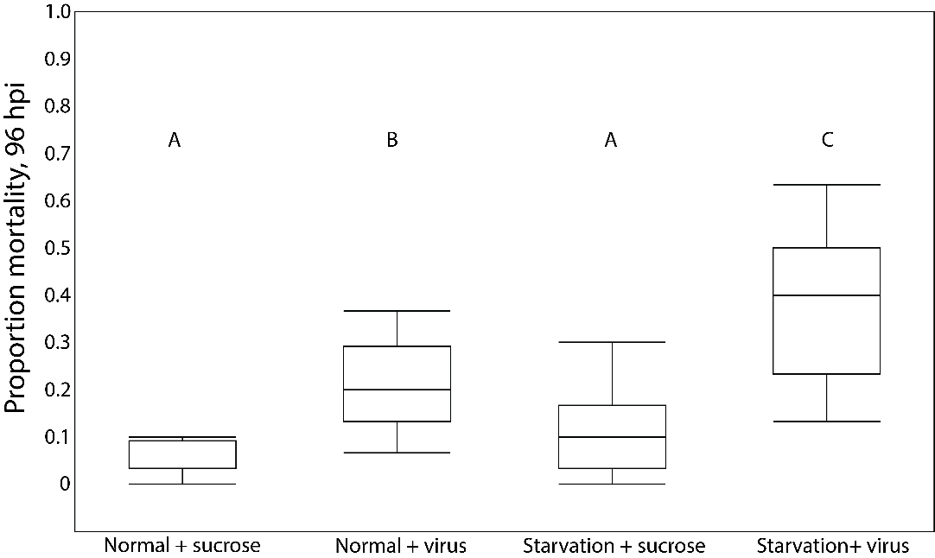

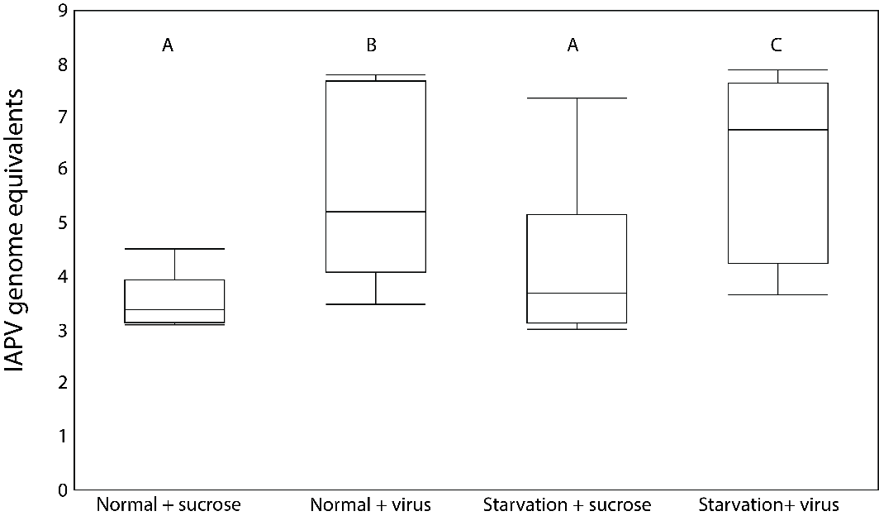

**Figure 1** A) Proportion mortality in cages of bees that experienced normal or starvation conditions during development fed sterile sucrose or virus inoculum as adults, 96 hours post inoculation (hpi); B) Estimated genome equivalents, calculated against a standard curve, of IAPV in pooled samples from randomly-selected cages from each treatment. Boxplots display median, interquartile range, and full data range. Letters denote significant differences (ANOVA followed by Tukey HSD, p<0.05).

Figure 2: Gene expression data from acute cages

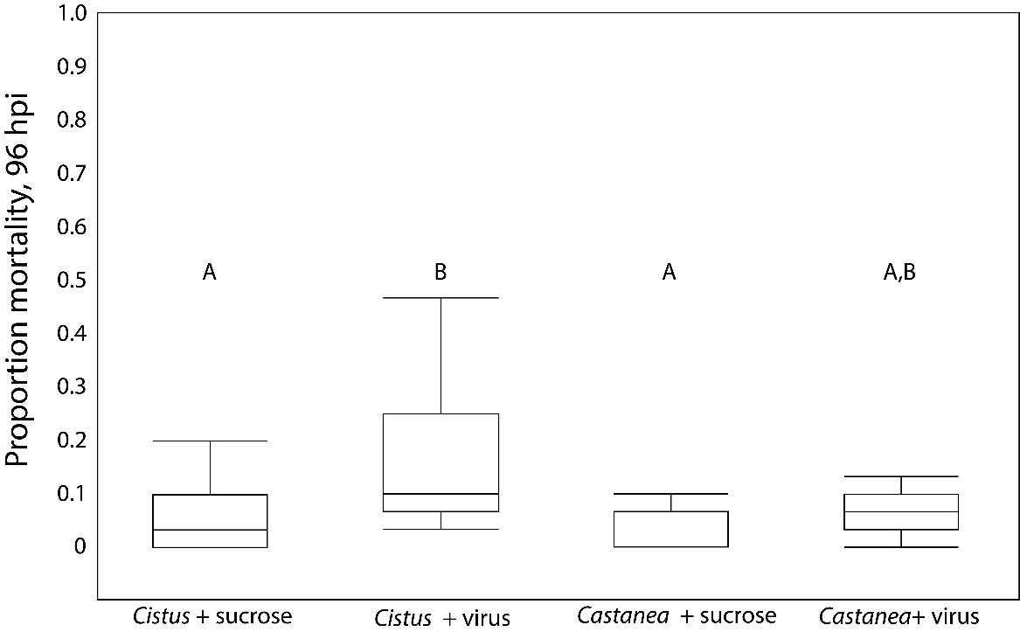

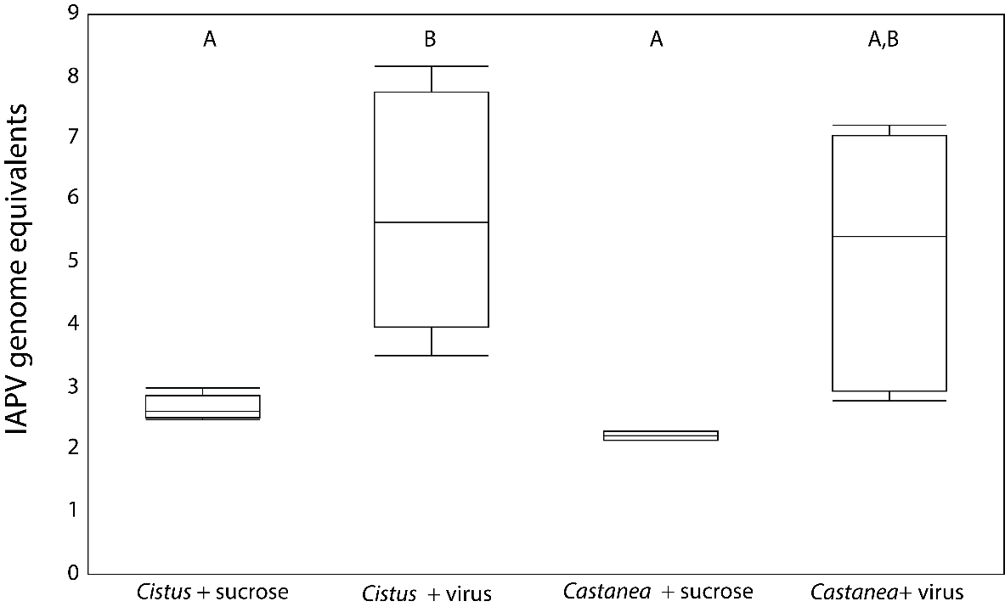

**Figure 3** A) Proportion mortality in cages of bees reared under *Cistus* or *Castanea*-only hive conditions fed sterile sucrose or virus inoculum as adults, 96 hours post inoculation (hpi); B) Estimated genome equivalents, calculated against a standard curve, of IAPV in pooled samples from randomly-selected cages from each treatment. Boxplots display median, interquartile range, and full data range. Letters denote significant differences (ANOVA followed by Tukey HSD, p<0.05).

**Figure 4: Chronic gene expression**

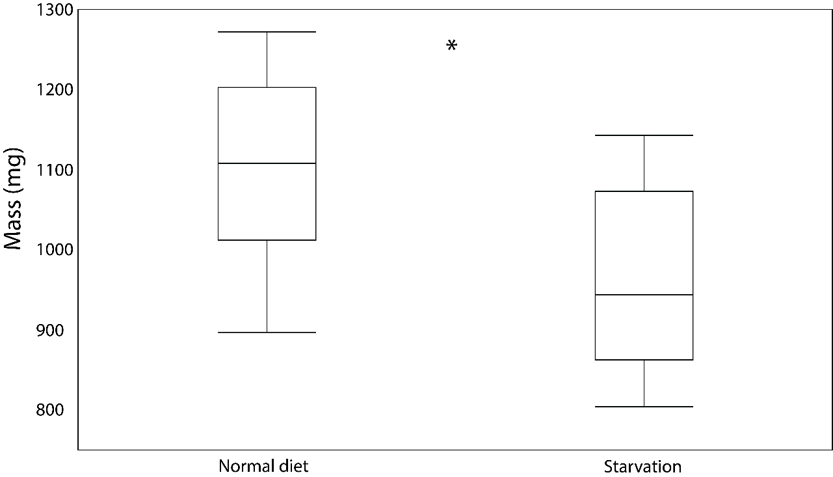

**Supplemental figure?:** Mass (mg) of bees reared under normal and starvation conditions. Boxplots display median, interquartile range, and full data range. Asterisk denotes significant difference (Welch’s t-test, p<0.05).

**probably should make this for Chronic even though its not significantly different

References

Alaux C., F. Allier, A. Decourtye, J.F. Odoux, T. Tamic, M. Chabirand, E. Delestra, et al. 2017. A â €’Landscape physiology’ approach for assessing bee health highlights the benefits of floral landscape enrichment and semi-natural habitats. Sci Rep.

Alaux C., F. Ducloz, D. Crauser, and Y. Le Conte. 2010. Diet effects on honeybee immunocompetence. Biol Lett.

Albon S.D., T.H. Clutton-Brock, and F.E. Guinness. 1987. Early Development and Population Dynamics in Red Deer. II. Density-Independent Effects and Cohort Variation. J Anim Ecol.

Barrett E.L.B., J. Hunt, A.J. Moore, and P.J. Moore. 2009. Separate and combined effects of nutrition during juvenile and sexual development on female life-history trajectories: the thrifty phenotype in a cockroach. Proc R Soc B Biol Sci 276:3257–3264.

Bates D., M. Mächler, B.M. Bolker, and S.C. Walker. 2015. Fitting linear mixed-effects models using lme4. J Stat Softw.

Binari R. and N. Perrimon. 1994. Stripe-specific regulation of pair-rule genes by hopscotch, a putative Jak family tyrosine kinase in Drosophila. Genes Dev.

Birkhead T.R., F. Fletcher, and E.J. Pellatt. 1999. Nestling diet, secondary sexual traits and fitness in the zebra finch. Proc R Soc B Biol Sci.

Briga M., E. Koetsier, J.J. Boonekamp, B. Jimeno, and S. Verhulst. 2017. Food availability affects adult survival trajectories depending on early developmental conditions. Proc R Soc B Biol Sci.

Burton T. and N.B. Metcalfe. 2014. Can environmental conditions experienced in early life influence future generations? Proc R Soc B Biol Sci. Royal Society of London.

Carr H.M., J.H. Palmer, and C.C. Rittschof. 2020. Honey bee aggression: evaluating causal links to disease-resistance traits and infection. Behav Ecol Sociobiol.

Carrillo-Tripp J., A.G. Dolezal, M.J. Goblirsch, W.A. Miller, A.L. Toth, and B.C. Bonning. 2016. In vivo and in vitro infection dynamics of honey bee viruses. Sci Rep.

Casteels P., C. Ampe, F. Jacobs, and P. Tempst. 1993. Functional and chemical characterization of hymenoptaecin, an antibacterial polypeptide that is infection-inducible in the honeybee (Apis mellifera). J Biol Chem.

Cerutti H. and J.A. Casas-Mollano. 2006. On the origin and functions of RNA-mediated silencing: From protists to man. Curr Genet.

Chen Y.P., J.S. Pettis, M. Corona, W.P. Chen, C.J. Li, M. Spivak, P.K. Visscher, et al. 2014. Israeli Acute Paralysis Virus: Epidemiology, Pathogenesis and Implications for Honey Bee Health. PLoS Pathog.

Corby-Harris V., B.M. Jones, A. Walton, M.R. Schwan, and K.E. Anderson. 2014. Transcriptional markers of sub-optimal nutrition in developing Apis mellifera nurse workers. BMC Genomics 15.

Corby-Harris V., C.A.D. Meador, L.A. Snyder, M.R. Schwan, P. Maes, B.M. Jones, A. Walton, et al. 2016. Transcriptional, translational, and physiological signatures of undernourished honey bees (Apis mellifera) suggest a role for hormonal factors in hypopharyngeal gland degradation. J Insect Physiol 85.

Corby-Harris V., L. Snyder, and C. Meador. 2019. Fat body lipolysis connects poor nutrition to hypopharyngeal gland degradation in Apis mellifera. J Insect Physiol.

Cox-Foster D.L., S. Conlan, E.C. Holmes, G. Palacios, J.D. Evans, N.A. Moran, P.L. Quan, et al. 2007. A metagenomic survey of microbes in honey bee colony collapse disorder. Science (80- ).

Crailsheim K., U. Riessberger, B. Blaschon, R. Nowogrodzki, and N. Hrassnigg. 1999. Short-term effects of simulated bad weather conditions upon the behaviour of food-storer honeybees during day and night (Apis mellifera carnica Pollmann). Apidologie.

DeGrandi-Hoffman G., Y. Chen, E. Huang, and M.H. Huang. 2010. The effect of diet on protein concentration, hypopharyngeal gland development and virus load in worker honey bees (Apis mellifera L.). J Insect Physiol.

DeGrandi-Hoffman G., Y. Chen, R. Rivera, M. Carroll, M. Chambers, G. Hidalgo, and E.W. de Jong. 2016. Honey bee colonies provided with natural forage have lower pathogen loads and higher overwinter survival than those fed protein supplements. Apidologie.

Di Pasquale G., M. Salignon, Y. Le Conte, L.P. Belzunces, A. Decourtye, A. Kretzschmar, S. Suchail, et al. 2013. Influence of Pollen Nutrition on Honey Bee Health: Do Pollen Quality and Diversity Matter? (J. Zeil, ed.)PLoS One 8:e72016.

Dolezal A.G., J. Carrillo-Tripp, W. Allen Miller, B.C. Bonning, and A.L. Toth. 2016a. Intensively cultivated landscape and varroa mite infestation are associated with reduced honey bee nutritional state. PLoS One.

Dolezal A.G., J. Carrillo-Tripp, T.M. Judd, W. Allen Miller, B.C. Bonning, and A.L. Toth. 2019a. Interacting stressors matter: Diet quality and virus infection in honeybee health. R Soc Open Sci.

Dolezal A.G., J. Carrillo-Tripp, W.A. Miller, B.C. Bonning, and A.L. Toth. 2016b. Pollen contaminated with field-relevant levels of cyhalothrin affects honey bee survival, nutritional physiology, and pollen consumption behavior. J Econ Entomol.

Dolezal A.G., A.L.S. Clair, G. Zhang, A.L. Toth, and M.E. O’Neal. 2019b. Native habitat mitigates feast–famine conditions faced by honey bees in an agricultural landscape. Proc Natl Acad Sci U S A 116:25147–25155.

Dolezal A.G. and A.L. Toth. 2018. Feedbacks between nutrition and disease in honey bee health. Curr Opin Insect Sci.

Emlen D.J. 1997. Alternative reproductive tactics and male-dimorphism in the horned beetle Onthophagus acuminatus (Coleoptera: Scarabaeidae). Behav Ecol Sociobiol.

Evans J.D., K. Aronstein, Y.P. Chen, C. Hetru, J.L. Imler, H. Jiang, M. Kanost, et al. 2006. Immune pathways and defence mechanisms in honey bees Apis mellifera. Insect Mol Biol.

Failla M.L. 2003. Trace elements and host defense: Recent advances and continuing challenges. J Nutr.

Filipiak M., K. Kuszewska, M. Asselman, B. Denisow, E. Stawiarz, M. Woyciechowski, and J. Weiner. 2017. Ecological stoichiometry of the honeybee: Pollen diversity and adequate species composition are needed to mitigate limitations imposed on the growth and development of bees by pollen quality. PLoS One.

Geffre A.C., T. Gernat, G.P. Harwood, B.M. Jones, D.M. Gysi, A.R. Hamilton, B.C. Bonning, et al. 2020. Honey bee virus causes context-dependent changes in host social behavior. Proc Natl Acad Sci U S A.

Gems D. and L. Partridge. 2008. Stress-Response Hormesis and Aging: “That which Does Not Kill Us Makes Us Stronger.” Cell Metab.

Gilbert S.F. 2017. Ecological Developmental Biology. Pp. 1–8 in eLS. John Wiley & Sons, Ltd, Chichester, UK.

Griffin R.M., A.D. Hayward, E. Bolund, A.A. Maklakov, and V. Lummaa. 2018. Sex differences in adult mortality rate mediated by early-life environmental conditions. Ecol Lett.

Grozinger C.M. and M.L. Flenniken. 2019. Bee Viruses: Ecology, Pathogenicity, and Impacts. Annu Rev Entomol.

Harlow H.F., R.O. Dodsworth, and M.K. Harlow. 1965. Total social isolation in monkeys. Proc Natl Acad Sci U S A.

Harwood G.P., K.E. Ihle, H. Salmela, and G. V. Amdam. 2017. Regulation of Honeybee Worker (Apis mellifera) Life Histories by Vitellogenin. Horm Brain Behav Third Ed.

Hothorn T., F. Bretz, and P. Westfall. 2008. Simultaneous inference in general parametric models. Biometrical J.

Ihle K.E., N.A. Baker, and G. V. Amdam. 2014. Insulin-like peptide response to nutritional input in honey bee workers. J Insect Physiol.

Jack C.J., S.S. Uppala, H.M. Lucas, and R.R. Sagili. 2016. Effects of pollen dilution on infection of Nosema ceranae in honey bees. J Insect Physiol 87:12–19.

Kriengwatana B., T.M. Farrell, S.D.T. Aitken, L. Garcia, and S.A. MacDougall-Shackleton. 2015. Early-life nutritional stress affects associative learning and spatial memory but not performance on a novel object test. Behaviour 152:195–218.

Kucharski R., J. Maleszka, S. Foret, and R. Maleszka. 2008. Nutritional control of reproductive status in honeybees via DNA methylation. Science (80- ).

Lenth R., H. Singmann, J. Love, P. Buerkner, and M. Herve. 2020. emmeans : Estimated Marginal Means, aka Least-Squares Means. R Packag version 115-15.

Lindström J. 1999. Early development and fitness in birds and mammals. Trends Ecol Evol.

Livak K.J. and T.D. Schmittgen. 2001. Analysis of relative gene expression data using real-time quantitative PCR and the 2-ΔΔCT method. Methods.

Lummaa V. and T. Clutton-Brock. 2002. Early development, survival and reproduction in humans. Trends Ecol Evol. Elsevier Ltd.

Maori E., N. Paldi, S. Shafir, H. Kalev, E. Tsur, E. Glick, and I. Sela. 2009. IAPV, a bee-affecting virus associated with colony collapse disorder can be silenced by dsRNA ingestion. Insect Mol Biol.

McMullan J.B. and M.J.F. Brown. 2006. The influence of small-cell brood combs on the morphometry of honeybees (Apis mellifera). Apidologie.

Meikle D. and M. Westberg. 2001. Maternal nutrition and reproduction of daughters in wild house mice (Mus musculus). Reproduction.

Metcalfe N.B. and P. Monaghan. 2001. Compensation for a bad start: Grow now, pay later? Trends Ecol Evol.

Mogren C.L., R.G. Danka, and K.B. Healy. 2019. Larval Pollen stress increases adult susceptibility to clothianidin in honey bees. Insects.

Monaghan P. 2008. Early growth conditions, phenotypic development and environmental change. Philos Trans R Soc B Biol Sci.

Mutti N.S., A.G. Dolezal, F. Wolschin, J.S. Mutti, K.S. Gill, and G. V. Amdam. 2011. IRS and tor nutrient-signaling pathways act via juvenile hormone to influence honey bee caste fate. J Exp Biol.

Naug D. 2009. Nutritional stress due to habitat loss may explain recent honeybee colony collapses. Biol Conserv.

Otto C.R.V., C.L. Roth, B.L. Carlson, and M.D. Smart. 2016. Land-use change reduces habitat suitability for supporting managed honey bee colonies in the Northern Great Plains. Proc Natl Acad Sci U S A.

Preston S.R., J.H. Palmer, J.W. Harrison, H.M. Carr, and C.C. Rittschof. 2019. The impacts of maternal stress on worker phenotypes in the honey bee. Apidologie.

Ramsey S.D., R. Ochoa, G. Bauchan, C. Gulbronson, J.D. Mowery, A. Cohen, D. Lim, et al. 2019. Varroa destructor feeds primarily on honey bee fat body tissue and not hemolymph. Proc Natl Acad Sci U S A.

Rembold H., B. Lackner, and I. Geistbeck. 1974. The chemical basis of honeybee, Apis mellifera, caste formation. Partial purification of queen bee determinator from royal jelly. J Insect Physiol.

Richard F.J., H.L. Holt, and C.M. Grozinger. 2012. Effects of immunostimulation on social behavior, chemical communication and genome-wide gene expression in honey bee workers (Apis mellifera). BMC Genomics.

Rittschof C.C., C.B. Coombs, M. Frazier, C.M. Grozinger, and G.E. Robinson. 2015. Early-life experience affects honey bee aggression and resilience to immune challenge. Sci Rep.

Rittschof C.C. and G.E. Robinson. 2013. Manipulation of colony environment modulates honey bee aggression and brain gene expression. Genes, Brain Behav.

Rittschof C.C., B.E.R. Rubin, and J.H. Palmer. 2019. The transcriptomic signature of low aggression in honey bees resembles a response to infection. BMC Genomics.

Roth A., C. Vleurinck, O. Netschitailo, V. Bauer, M. Otte, O. Kaftanoglu, R.E. Page, et al. 2019. A genetic switch for worker nutritionmediated traits in honeybees. PLoS Biol.

Rutter L., J. Carrillo-Tripp, B.C. Bonning, D. Cook, A.L. Toth, and A.G. Dolezal. 2019. Transcriptomic responses to diet quality and viral infection in Apis mellifera. BMC Genomics.

Ryabov E. V., J.M. Fannon, J.D. Moore, G.R. Wood, and D.J. Evans. 2016. The Iflaviruses Sacbrood virus and Deformed wing virus evoke different transcriptional responses in the honeybee which may facilitate their horizontal or vertical transmission. PeerJ.

Schmickl T. and K. Crailsheim. 2001. Cannibalism and early capping: Strategy of honeybee colonies in times of experimental pollen shortages. J Comp Physiol - A Sensory, Neural, Behav Physiol.

Schmidt J.O., S.C. Thoenes, and M.D. Levin. 1987. Survival of Honey Bees, Apis mellifera (Hymenoptera: Apidae), Fed Various Pollen Sources. Ann Entomol Soc Am.

Schmidt L.S., J.O. Schmidt, Rao Hima, Wang Weiyi, and Xu Ligen. 1995. Feeding preference and survival of young worker honey bees (Hymenoptera: Apidae) fed rape, sesame, and sunflower pollen. J Econ Entomol.

Scofield H.N. and H.R. Mattila. 2015. Honey bee workers that are pollen stressed as larvae become poor foragers and waggle dancers as adults. PLoS One.

Siede R., M.D. Meixner, and R. Büchler. 2012. Comparison of transcriptional changes of immune genes to experimental challenge in the honey bee (Apis mellifera). J Apic Res.

Slater G.P., G.D. Yocum, and J.H. Bowsher. 2020. Diet quantity influences caste determination in honeybees (Apis mellifera). Proceedings Biol Sci.

Smart M., J. Pettis, N. Rice, Z. Browning, and M. Spivak. 2016a. Linking measures of colony and individual honey bee health to survival among apiaries exposed to varying agricultural land use. PLoS One.

Smart M.D., C.R.V. Otto, and J.G. Lundgren. 2019. Nutritional status of honey bee (Apis mellifera L.) workers across an agricultural land-use gradient. Sci Rep.

Smart M.D., J.S. Pettis, N. Euliss, and M.S. Spivak. 2016b. Land use in the Northern Great Plains region of the U.S. influences the survival and productivity of honey bee colonies. Agric Ecosyst Environ.

St Clair A.L., G. Zhang, A.G. Dolezal, M.E. O’Neal, and A.L. Toth. 2020. Diversified Farming in a Monoculture Landscape: Effects on Honey Bee Health and Wild Bee Communities. Environ Entomol.

Team R.C. 2016. R: A Language and Environment for Statistical Computing. R Found Stat Comput.

Teicher M.H., S.L. Andersen, A. Polcari, C.M. Anderson, C.P. Navalta, and D.M. Kim. 2003. The neurobiological consequences of early stress and childhood maltreatment. Neurosci Biobehav Rev.

Toth A.L., S. Kantarovich, A.F. Meisel, and G.E. Robinson. 2005. Nutritional status influences socially regulated foraging ontogeny in honey bees. J Exp Biol.

Toth A.L. and G.E. Robinson. 2005. Worker nutrition and division of labour in honeybees. Anim Behav 69:427–435.

Traynor K.S., F. Mondet, J.R. de Miranda, M. Techer, V. Kowallik, M.A.Y. Oddie, P. Chantawannakul, et al. 2020. Varroa destructor: A Complex Parasite, Crippling Honey Bees Worldwide. Trends Parasitol.

Valanne S., J.-H. Wang, and M. Rämet. 2011. The Drosophila Toll Signaling Pathway . J Immunol.

Walton A., A.G. Dolezal, M.A. Bakken, and A.L. Toth. 2018. Hungry for the queen: Honeybee nutritional environment affects worker pheromone response in a life stage-dependent manner. Funct Ecol.

Walton A., J.M. Jandt, and A. Dornhaus. 2019. Guard bees are more likely to act as undertakers: variation in corpse removal in the bumble bee Bombus impatiens. Insectes Soc.

Wang T., C.C.Y. Hung, and D.J. Randall. 2006. THE COMPARATIVE PHYSIOLOGY OF FOOD DEPRIVATION: From Feast to Famine. Annu Rev Physiol 68:223–251.

Wang Y., J.B. Campbell, O. Kaftanoglu, R.E. Page, G. V. Amdam, and J.F. Harrison. 2016a. Larval starvation improves metabolic response to adult starvation in honey bees (Apis mellifera L.). J Exp Biol 219:960–968.

Wang Y., O. Kaftanoglu, C.S. Brent, R.E. Page, and G. V. Amdam. 2016b. Starvation stress during larval development facilitates an adaptive response in adult worker honey bees (Apis mellifera L.). J Exp Biol.

Wang Y., O. Kaftanoglu, M.K. Fondrk, and R.E. Page. 2014. Nurse bee behaviour manipulates worker honeybee (Apis mellifera L.) reproductive development. Anim Behav 92:253–261.

Wright G.A., S.W. Nicolson, and S. Shafir. 2018. Nutritional Physiology and Ecology of Honey Bees. Annu Rev Entomol.